Brookside Surgery

www.brooksidesurgery.co.uk

Changes planned for Dispensary
We are awaiting local IT approval for new and innovative software for our dispensary which will bring improvements to the processing of requests for repeat medications. This is a costly but necessary move to keep apace of the increasing numbers of items processed by the dispensary each month. Please keep an eye on our social media pages for the latest information as there will be times during the installation process that we will be asking for your co-operation and patience.
In the meantime, please allow FIVE WORKING days between ordering and collection unless you receive a text message sooner.

Medications while on holiday
If you are fortunate enough to be going on holiday, then please ensure you order enough medication to last while you are away and most importantly don’t forget to take it with you. If you travel within the UK and need medication urgently then you may be able to get supplies from a pharmacy or you will need to register as a temporary patient with a local GP. We are not able to electronically send prescriptions from our system.

Friends and family test (FFT)
Please feel free to complete the Friends and Family test whenever you have an interaction the Practice. It can be found on our website or you may receive a text directly. This gives us timely and important feedback on the service and care we are providing. Result for May were:

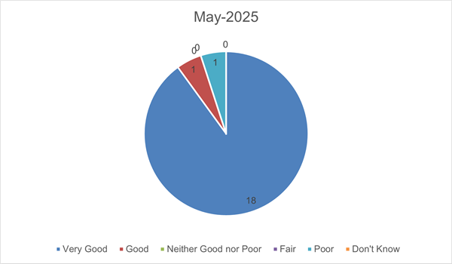

Blood pressure readings
After consultation with our Patient Group and considering the increasing cost of the ongoing software licence and support, it has been decided to remove the BP machine from the waiting room. The number of patients using this has fallen significantly and we believe that it is not the best way to get accurate blood pressure readings as patients not always relaxed when using the machine. We are more than happy to provide appointments with either of our nurses or GP Assistant or we also suggest that home readings can be more accurate.

Coventry & Warwickshire Integrated Care Board (ICB) statement on ADHD assessments
The ICB has written to all Coventry and Warwickshire GPs regarding a change to its policy on referral for assessment of ADHD. At present, over 7,500 children and young people in Coventry and Warwickshire are awaiting assessment, with some facing waiting periods exceeding ten years.
To address these challenges, the ICB are committed to implementing a comprehensive transformation programme for ADHD services. While this long-term work is being carried out, the ICB has taken immediate steps to alleviate the backlog. With immediate effect, the ICB will only commission new ADHD referrals for individuals aged under 25, including Independent Sector Right to Choose organisations and Coventry and Warwickshire Partnership Trust (CWPT). Full statement is available at STATEMENT ON ADHD ASSESSMENT POLICY IN COVENTRY AND WARWICKSHIRE - Happy Healthy Lives

Staffing
Dr Harriet Tuite-Dalton has now completed her GP training and taken up a post in a surgery in Cambridgeshire. Although we are sad to see her go, we wish her all the best and are pleased she will have a much shorter commute.

Training
The Practice will be closed on Wednesday 16th July between 1.00 – 5.00 pm for training.

