**Brookside Surgery**

**www.brooksidesurgery.co.uk**

**Dispensary Update**

The staff in the dispensary continue to look for ways of improving the service offered to our patients. Over the summer months we will be working towards implementing new systems that will build on this progress. One area that has been highlighted as a safety concern is the use of an answerphone for patient requests and we strongly urge all patients to register with the NHS App so that medication can be ordered electronically. We realise not everyone has a smartphone and are working with our patient group to ensure there is a safe and efficient way for these patients to contact the dispensary and order their medications. In the meantime, if we could ask that patients help us by:-

* Ordering repeat medication at least FIVE WORKING DAYS before you need to collect it.
* Register for the NHS app and order medication through this.
* Collect your medication promptly. Either five working days after ordering or when sooner if you receive a text message. We now have a large amount of medication awaiting collection and are running out of space!
* Avoid collecting medication on a Friday (particularly in the afternoon). This is when you are most likely to have to queue so if you can please collect on a different day.

**NHS App**

The NHS App allows you to order prescriptions and book some appointments online. You can sign up remotely with no need to bring your ID to the surgery. Over the coming months there is a plan for more detailed information from your medical records to be available. We would encourage all patients to sign up to the NHS App. If you already have a Patient Access account then you can also sign up to the NHS App really easily.

**Friends and family test (FFT)**

Please feel free to complete the Friends and Family test whenever you have an interaction the Practice. It can be found on our website or you may receive a text directly. This gives us timely and important feedback on the service and care we are providing. Result for May were:

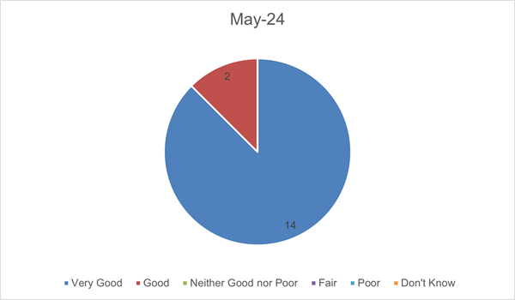

**Staffing**

In July we will say goodbye to Shyla as she is off to Nottingham Trent University to study Business Studies but we hope to see her back with us during her summer vacation time at least.

We currently have a vacancy for a Dispenser/Counter Assistant in dispensary and a Patient Liaison assistant in reception. Please contact the Practice Manager if you would like more information or search “Brookside Surgery” on Indeed or NHS Jobs.

**Training**

The Practice will be closed on Wednesday 24th July between 1.00 – 5.00 pm for training.